

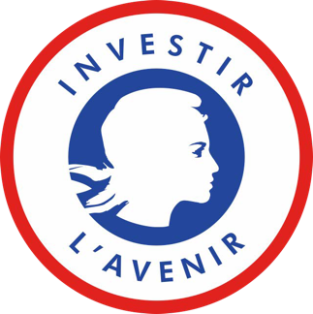


Application Form

Digital Public Health PhD extension grant

Bordeaux 2026




APPLICATION FORM

Academic year 2026/2027

NAME – First Name:

Education:
Baccalauréat or equivalent degree Year
University
University or institution
List your degrees from your high school diploma to your university degree(s)

Year | Degree / cursus | Grade / rank | University / institution | Country

Research
roject
Specialty:
Name of PhD supervisor:
Name of PhD co-supervisor (if any):
Email:

Thesis subject:

Research unit:

Team:

Signature:
Date:
commit to supervised:
I,
Thesis supervisor’s recommendation on the research and necessity of the grant:
Signature:
Date:
Research Team manager’s recommendation on the research and necessity of the grant:

Section A

NAME: First Name(s):

Date of Birth:
Civility :

Country of Birth:

Nationality:

Male Female Non-binary
E-mail:
Contact address:

Phone number: (please specifiy the international prefix)

Section B

B.1

French master degree or any other equivalent French degree
f

Degree’s title:
Discipline:
Date of graduation:
University:
Grade (mention):
Title of master’s dissertation and name of supervisor:

Master degree from any other country

Degree’s title:
Discipline:
Date of graduation:
University:
Grade (or ranking):
Title of master’s dissertation and name of supervisor (if relevant):

Students awarded a « validation des acquis » under article L. 613-5 of the code de l'éducation (please join all supporting documents of the validation) - only available to French students
Other higher education degrees (undergraduate and/or degrees awarded in other disciplines)

Section F: Research & extension
Requested extension length:

Thesis title:

Summary of research conducted to date
Provide a summary of the research activities conducted during the initial period of your PhD.
Your research, papers…

9/19
Research Impact & Outreach
Outline the potential for knowledge transfer or practical applications of your work.
Participation to conferences…

10/19

Work plan for the requested period
Outline the specific tasks and milestones to be completed during the requested extension.

11/1

Future research trajectory/ Postdoctoral plans
Outline any potential postdoctoral projects or research directions you plan to pursue after your defense.

CONTACT

dph@u-bordeaux.fr

